## **Requirement Gathering and Analysis Phase**

## **Data Flow Diagram & User Stories**

***Date :***27 July 2025

***Team ID:*** LTVIP2025TMID58557

***Project Name:*** FreelanceFinder

## **Data Flow Diagram:**

A Data Flow Diagram (DFD) is a traditional visual representation of the information flows within a system. A neat and clear DFD can depict the right amount of the system requirement graphically. It shows how data enters and leaves the system, what changes the information, and where data is stored.

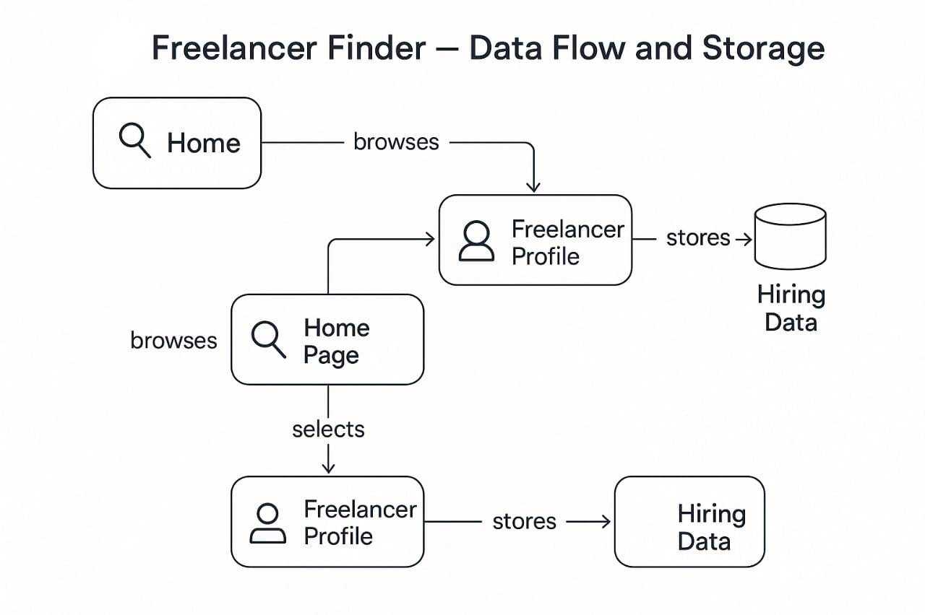

**Data Flow Diagram summary:**

1. **User** visits the **Home Page** and browses available freelancers.
2. They select a **Freelancer Profile** to view more details.
3. Once interested, the user may initiate hiring.
4. The action is processed and **hiring data is stored** in the database.
5. The flow loops from browsing to storing based on interactions.
6. It visually connects frontend navigation with backend data handling.

## User Stories – Freelancer Finder

| **User Type** | **Functional Requirement (Epic)** | **User Story No.** | **User Story / Task** | **Acceptance Criteria** | **Priority** | **Release** |
| --- | --- | --- | --- | --- | --- | --- |
| Client (Web) | Search & Hire Freelancers | FF-US-1 | As a user, I want to search and filter freelancers by skill and location. | I can find freelancers matching criteria | High | Sprint-1 |
| Client (Web/Mobile) | Account Management | FF-US-2 | As a user, I want to sign up, log in, and manage my account securely. | I can access my dashboard securely | High | Sprint-1 |
| Client | Freelancer Profiles | FF-US-3 | As a user, I want to view freelancer profiles with details and ratings. | I can see skills, experience, and feedback of freelancers | High | Sprint-1 |
| Client | Chat & Communication | FF-US-4 | As a user, I want to chat with freelancers before hiring. | I can send/receive real-time messages | Medium | Sprint-2 |
| Freelancer | Project Application | FF-US-5 | As a freelancer, I want to view available projects and apply with a custom message. | I can submit an application and track status | High | Sprint-2 |
| Admin | User Management | FF-US-6 | As an admin, I want to manage users, freelancers, and reported activity. | I can add/block/edit accounts | High | Sprint-3 |
| Freelancer | Profile Creation | FF-US-7 | As a freelancer, I want to create and update my profile and skills. | My profile is visible to clients | High | Sprint-1 |
| Client | Notifications | FF-US-8 | As a user, I want to get notified when a freelancer replies or project status updates. | I receive relevant updates | Medium | Sprint-3 |
| Client & Freelancer | Security & Verification | FF-US-9 | As a user/freelancer, I want to know the platform is safe and verified. | I interact only with verified users | High | Sprint-3 |